Infrastructure Analysis: Drinking Water Access in Sub-Saharan Africa

Introduction
The Water Project is a non-governmental organization (NGO) focused on improving access to safe drinking water in countries around the world, particularly in Sub-Saharan Africa. Access to reliable drinking water is essential for public health, economic development, and long-term sustainability. Many countries in Sub-Saharan Africa continue to face challenges related to water infrastructure, water quality, and equitable access to drinking water sources.
The objective of this project is to analyze the JMP Household Drinking Water dataset in order to evaluate trends in drinking water access across countries in the Sub-Saharan Africa region. Python was used to organize, analyze, and visualize the dataset to identify patterns and differences in water access between countries over time. The results of this project are intended to support engineering and infrastructure decision-making by helping identify areas where improvements in drinking water access are still needed.
Methods
Several variables were selected from the JMP Household Drinking Water dataset, including country, year, region, and percentage of population with access to basic drinking water services. Country and regional classifications were selected to compare trends between locations within Sub-Saharan Africa. The year variable was used to evaluate how drinking water access has changed over time. The percentage of the population with access to drinking water services was selected because it directly measures the availability of water infrastructure.
Python was used throughout the project to import, organize, clean, and analyze the JMP Household Drinking Water dataset. The dataset was imported using pandas, and unnecessary columns or missing values were removed during the data cleaning process. Data filtering and grouping techniques were then used to isolate countries within the Sub-Saharan Africa region and compare changes in drinking water access over time.
Matplotlib and seaborn were used to create visualizations including summary figures, time-series plots, grouped bar charts, and geographic maps. Grouping and aggregation methods were applied to compare drinking water access percentages between countries and across years. The visualizations were customized with titles, labels, legends, and formatting to clearly communicate trends and differences in water access.
Description of Plots
Figure 1 is a time-series plot showing changes in drinking water access percentages over time for selected countries in Sub-Saharan Africa. The plot allows direct comparison of long-term trends between countries and demonstrates how drinking water access has changed over time.
Figure 1: Drinking Water Access Over Time
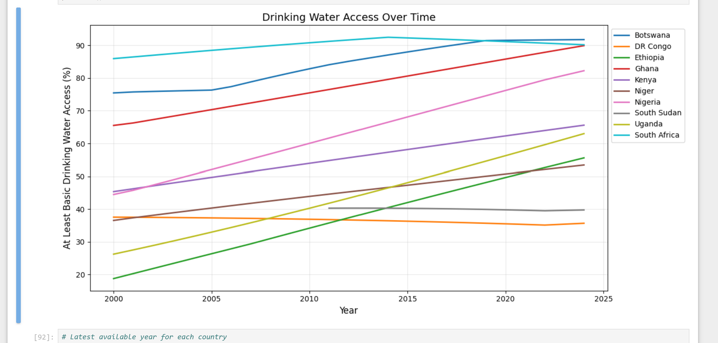
Figure 2 is a bar chart comparing the latest available drinking water access percentages for selected countries in Sub-Saharan Africa. The chart highlights differences in current drinking water infrastructure and accessibility between countries.
Figure 2: Latest Available Drinking Water Access by Country
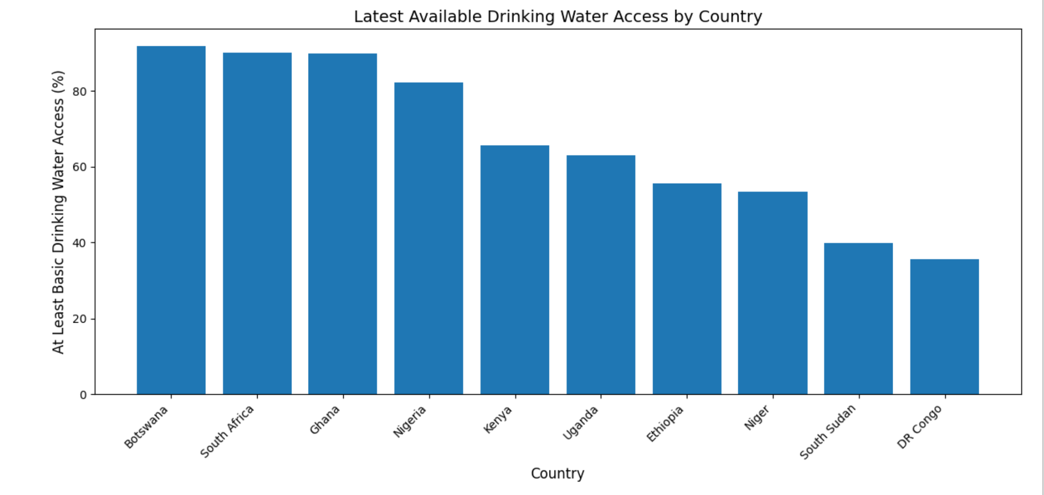
Figure 3 consists of grouped bar charts comparing urban and rural drinking water access percentages during different time periods including 2000–2002, 2010–2012, and 2020–2022. These visualizations demonstrate disparities in infrastructure access between urban and rural areas and show how these differences have changed over time.
Figure 3: Urban and Rural Drinking Water Access (2000-2022)
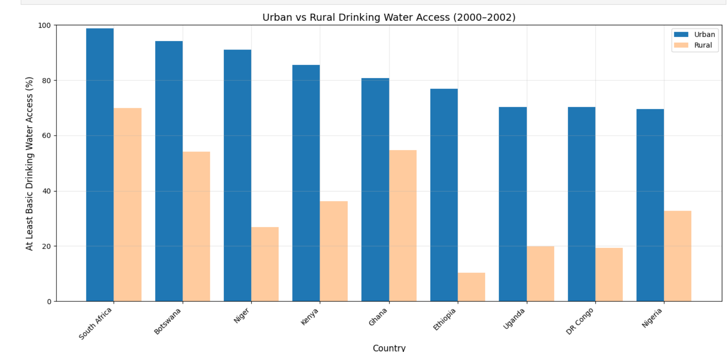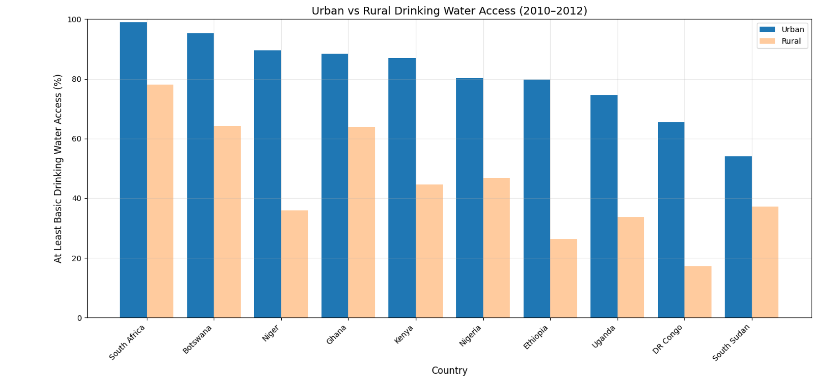
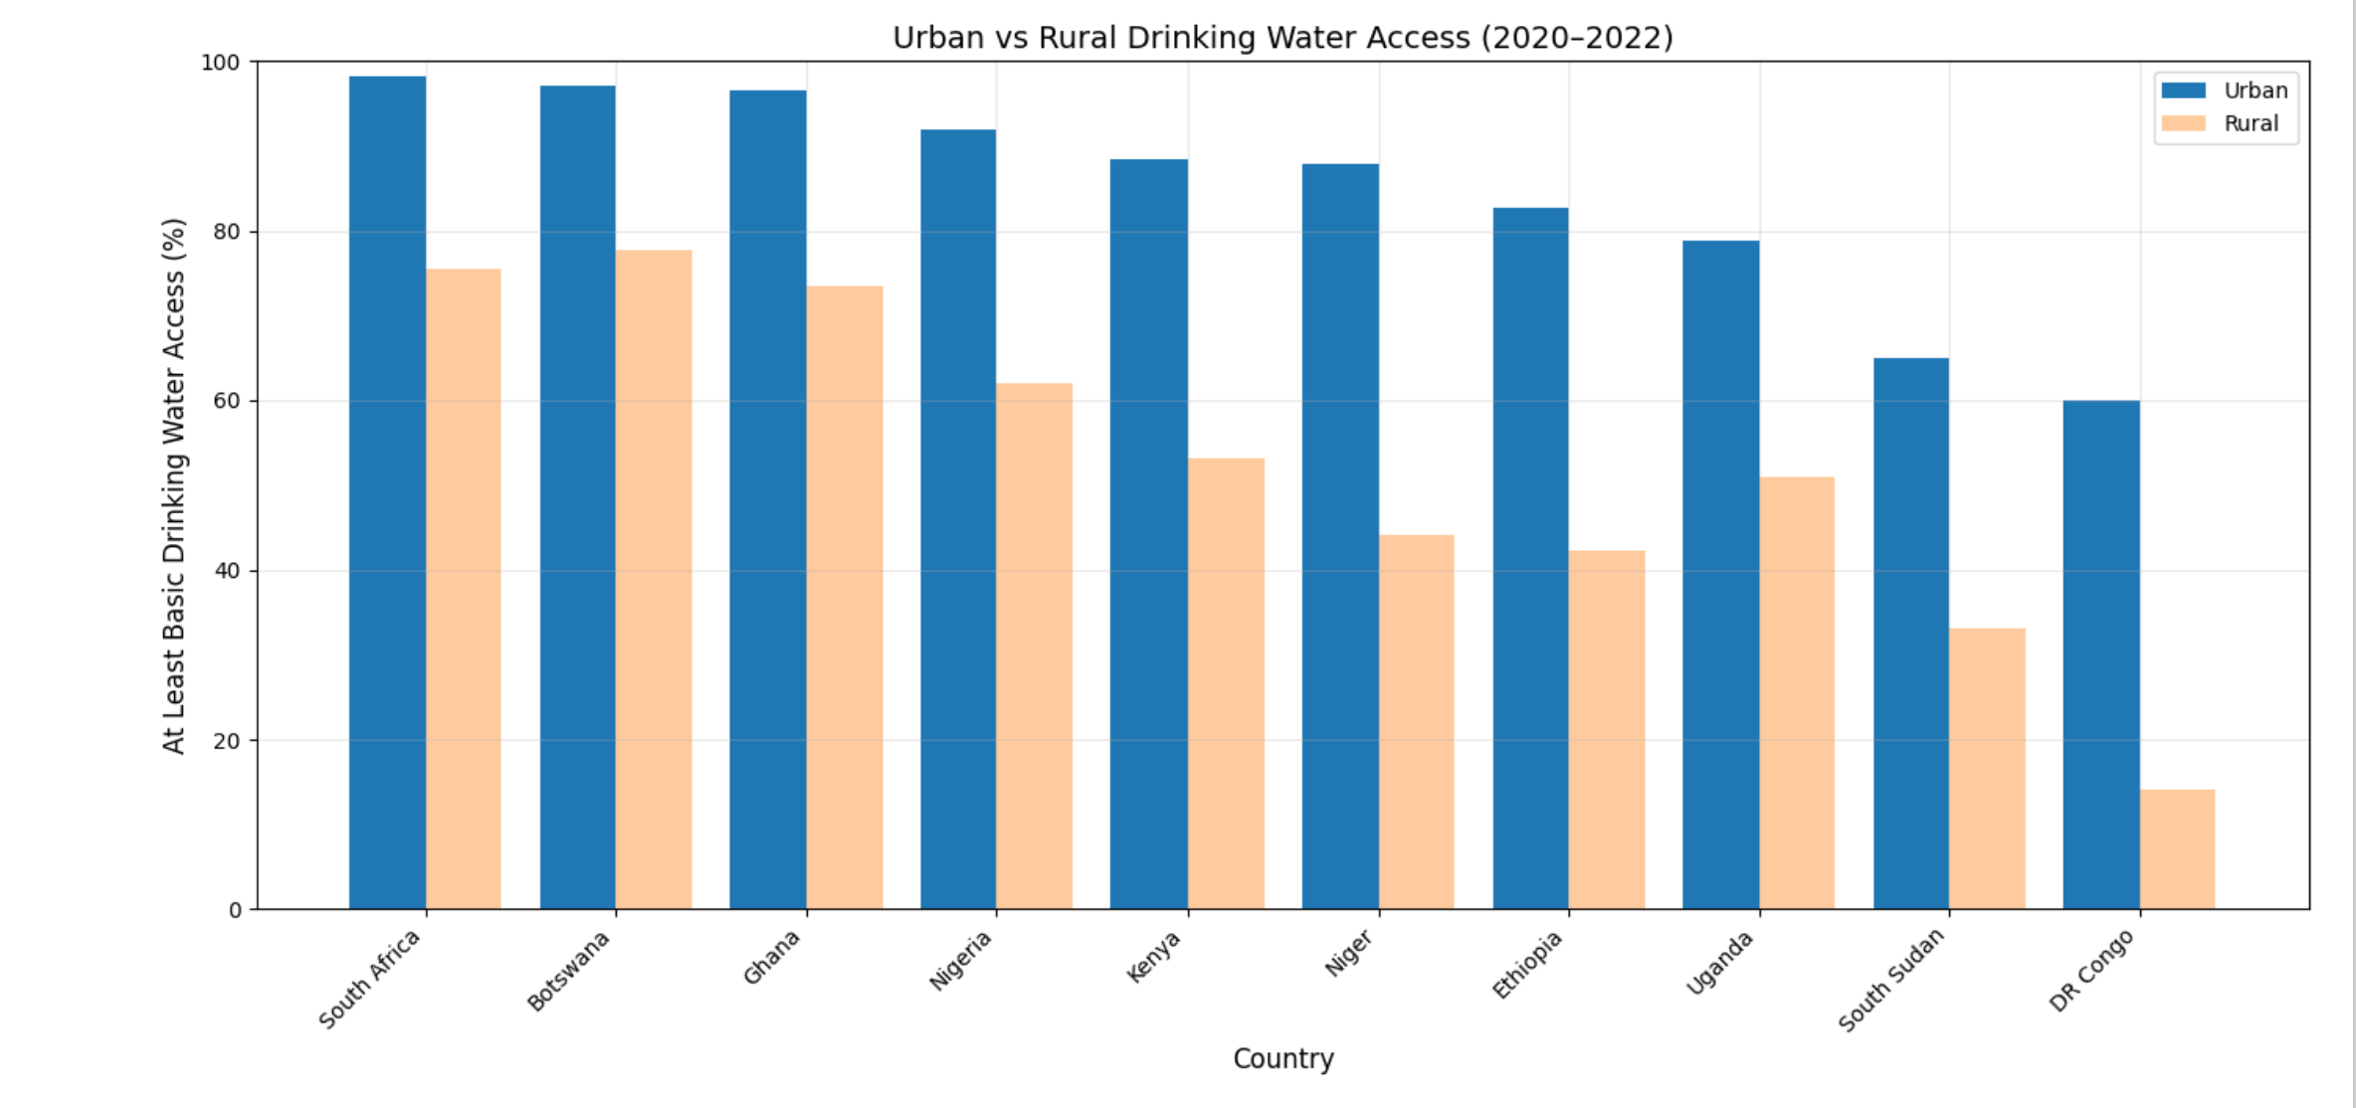
Figure 4 consists of geographic maps displaying drinking water access percentages across countries in Sub-Saharan Africa. Color shading was used to represent varying levels of access, with darker colors indicating higher percentages of drinking water access.
Figure 4: Drinking Water Access Across Sub-Saharan Africa
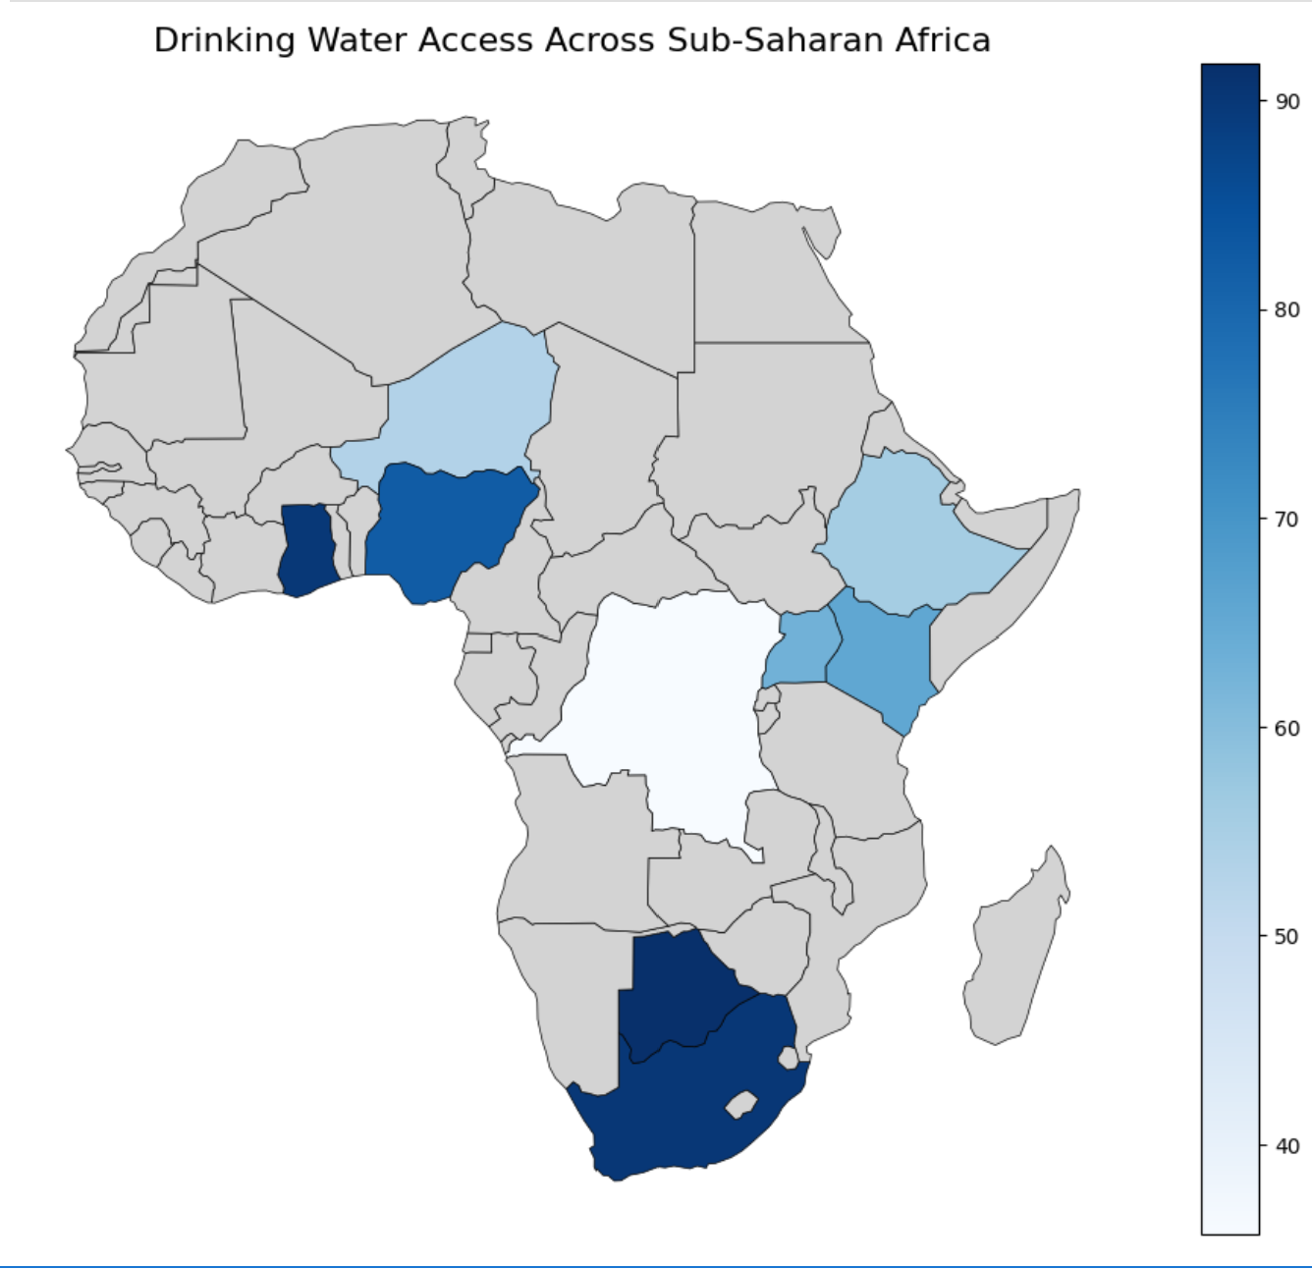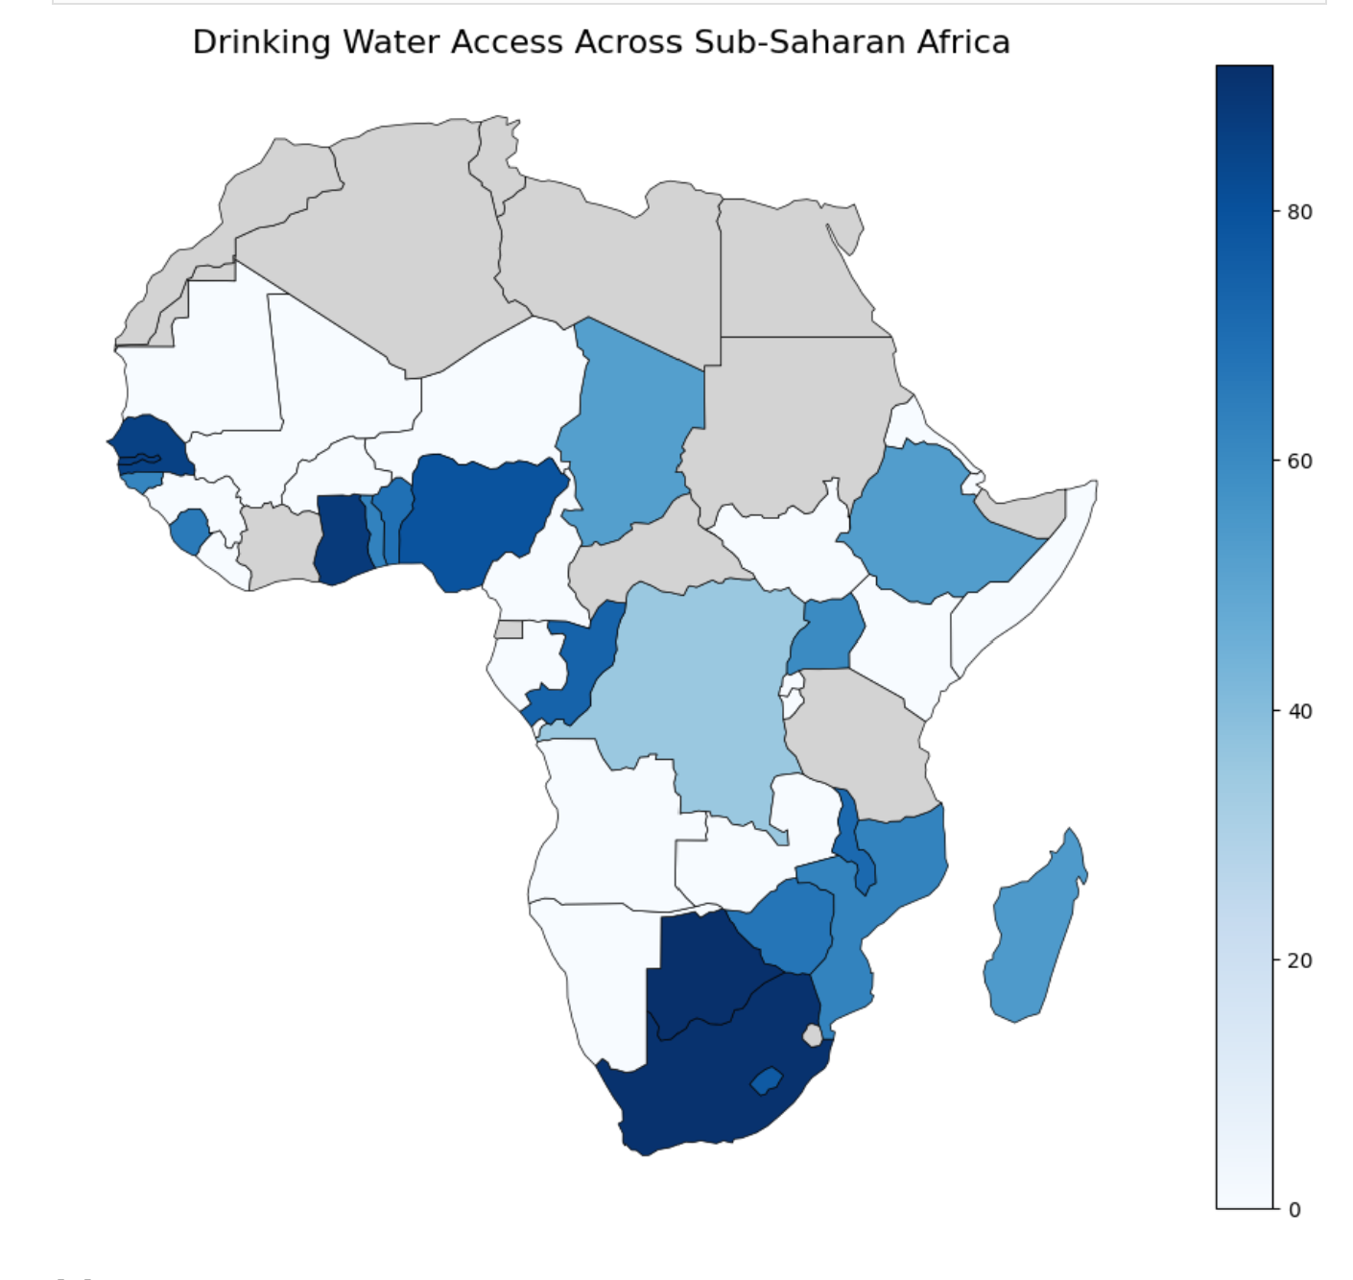
Results and Discussion
The visualizations show trends in drinking water access across different countries and regions within Sub-Saharan Africa. The results demonstrate how access to clean water varies depending on economic development, infrastructure investment, and regional conditions. These differences are important because they directly impact public health, environmental sustainability, and long-term infrastructure planning.
Figure 1 shows that most countries experienced improvements in drinking water access over time. Botswana, South Africa, and Ghana consistently maintained some of the highest drinking water access percentages throughout the dataset, with values approaching or exceeding 90% by the most recent years. Ethiopia, Uganda, and Nigeria also showed significant improvements over time, indicating progress in water infrastructure development. In contrast, countries such as DR Congo and South Sudan maintained lower drinking water access percentages, demonstrating that challenges related to infrastructure and accessibility still exist in some regions.
Figure 2 highlights the differences in the latest available drinking water access percentages between countries. Botswana, South Africa, and Ghana had the highest percentages of drinking water access among the countries analyzed. Ethiopia, Niger, and South Sudan showed lower percentages in comparison, indicating that access to drinking water infrastructure remains uneven across Sub-Saharan Africa.
Figure 3 demonstrates clear differences between urban and rural drinking water access across multiple countries and time periods. Urban areas consistently showed higher percentages of drinking water access than rural areas. While both urban and rural access generally improved over time, the gap between urban and rural populations remained noticeable in several countries, particularly in Ethiopia, Niger, and DR Congo.
Figure 4 provides a geographic visualization of drinking water access across Sub-Saharan Africa. Countries with darker shading generally had higher levels of drinking water access, while lighter shaded countries had lower access percentages. Southern African countries such as South Africa and Botswana showed relatively high levels of drinking water access, while several central and eastern African countries showed lower access levels.
The results of this project demonstrate how Python-based data analysis can be used to support engineering decision-making and identify important global trends. Understanding differences in water access and sanitation infrastructure can help engineers and policymakers prioritize future improvements and support sustainable development goals.
The coding and analysis choices made during this project can influence the results and conclusions of the study. One major decision involved selecting only 10 countries for the detailed analysis rather than every country in Sub-Saharan Africa. This made the graphs easier to read and easier for Python to handle but this is still a biased comparison. A better comparison would be able to use all the countries. Still, we included a small GeoPandas map of all the countries data just for clarification purposes and we thought this way would be better at conveying it instead of using bar or time series graphs.
Another coding decision involved using the Basic_Access variable created by combining Basic service and Safely managed service percentages. Different definitions of drinking water access could produce different results and interpretations. Also, some countries had missing years or inconsistent reporting which can affect comparisons and results.
Ethically, it is important to recognize that data visualizations can influence how people interpret infrastructure problems. Choices involving graph type, scaling, colors, and selected countries can unintentionally bias the interpretation of results. Because of this, the project attempted to use consistent scales, clear labels, and transparent data cleaning methods throughout the analysis. An inconsistent project would create more questions.

References
JMP Household Drinking Water Data. https://washdata.org/data
The Water Project. https://thewaterproject.org/
World Bank Open Data.
United Nations Sustainable Development Goals (SDG 6).

